**Acknowledgements: Brian Low is the original creator of the Sofle Choc, you can find his site here:** [**https://choc.brianlow.com/**](https://choc.brianlow.com/)**; at lot of useful help is there.**

**If you got to this QSG, you most likely purchased one of my keyboard builds from** [**https://hirocan.xyz**](https://hirocan.xyz) **(if not, check it out!)**

**The purpose of this document is to help get you up and running using your brand new Sofle Choc, especially targeted towards someone new to the world of custom ergonomic keyboards.**

**Setting it up: *Right out of the box…***

If you purchased a complete build from ***hirocan***, switches and keycaps will already be installed and firmware flashed, so all you really need to do is plug in some cables!

First, find the TRRS cable (looks like an audio/aux cable) and plug in both halves of the keyboard together via the TRRS jacks found in the inside middle section of the boards.

Very important (so important, I will even highlight in red again later): Always plug in the TRSS cables first, then plug the USB C cable to the left half of the keyboard to the computer. **Doing it backwards: i.e. USB C then TRRS cable, may damage your board!!!**

**Remapping: *Is a breeze with VIA…***

After plugging in your keyboard as instructed in the first section, now’s the time to remap the keys to your liking. Remapping is done using the VIA app from [www.caniusevia.com](http://www.caniusevia.com) (click on “Try Now!”, or use the direct link here <https://usevia.app/>). You will need to click “Authorize Device” to connect to your Sofle.

Alternatively, you can also download a desktop version of the app, the benefit is that you don’t have to “Authorize Device” each time you use it: <https://github.com/the-via/releases/releases/tag/v3.0.0>

On the top middle menu, you will see three icons:

From left to right: 1. **Configure** (remapping) 2. **Key Tester** 3. **Settings**

**Before you remap any keys, it is highly recommended to save the current keymap under Configure --> Save + Load. You can always reflash the QMK firmware that shipped with the board if you want to get it back to the default state if you forget to do this (see later section).**

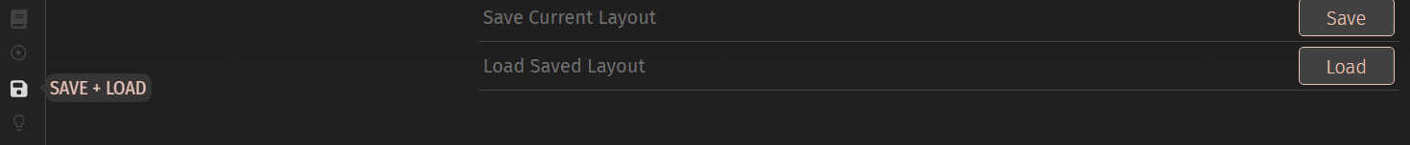

The remapping is pretty self-explanatory/intuitive: under **Configure**, first select the layer you want to remap. The default/first layer is layer 0, with 4 layers total (this is the max number of layers due to the space that VIA takes up in the firmware).



Click on a key that you want to remap on the digital representation of your keyboard, and then click on another key from the bottom menu below (broken up into several different categories) to remap. An adjacent key will automatically be selected after remapping, this is meant to help you quickly remap a series a keys without have to go back and click on the digital map; however, if you’re not paying attention this might cause you to accidently remap an unintended key, so be careful.

Besides going to the official docs for further remapping details, (<https://www.caniusevia.com/docs/specification>), here are some useful external links (these links feature keyboards other than Sofle, but the concept is still the same):

<https://www.keychron.com/blogs/archived/how-to-use-via-to-program-your-keyboard>

<https://docs.keeb.io/via>

The **Key Tester** is very helpful after you swap out keyswitches to test if you got them all back in correctly, and for other hardware related troubleshooting.

**Flashing: *If things go wrong…***

Your keyboard comes flashed with QMK + VIA firmware. The VIA addon makes it possible to remap your keys *“on the fly”.* There are a couple of downsides in doing it this way though: not all QMK actions/features are available under VIA, and VIA takes up memory/storage on the microcontroller. However, on the upside, is the already mentioned “*on the fly*” remapping which still has a lot of options, and you don’t have to worry about all the hassles with manually editing a keymap file and recompiling and reflashing.

All that being said, the reflashing instructions here are only meant to guide you in recovering from an error state (kind of like a failsafe). I have found that VIA covers the use cases for most users could possibly want. Therefore, using QMK to remap is out of scope of this help document. Please see <https://docs.qmk.fm/> if you want to take a deep dive on QMK.

Enough with the background info, here are the instructions!

First, download QMK toolbox:

<https://github.com/qmk/qmk_toolbox/releases/tag/0.2.2>

When installing QMK Toolbox, you will most likely get a blue window warning from Microsoft Defender that it's unrecognized, it is OK to install so just click the "More info" button then "Run anyway".

Once you have QMK toolbox installed, make sure the script that installs all the drives runs.

Next, make sure QMK toolbox is open. **Unplug the Sofle, AND unplug the TRRS cable.**

Now plug the USB-C of the right-hand board first. Press the reset button (small tactile switch just above the TRRS slot)

In QMK toolbox, set the handedness to "Right hand" as shown in the screenshot below.

Next, flash the firmware (.hex file) you just downloaded. If the "Flash" button is greyed out, just press the reset button on board and it should be clickable (as show in the screenshot below).

Repeat the same process for the left-hand side: i.e. plug in the left hand side only, set the handedness and flash the exact same .hex file (**do NOT connect the board yet with the TRRS cable**).

Now, disconnect the USB cable for the left-hand side. **Always connect the TRRS cable to the boards first before connecting to your computer**, before you plug in the USB C cable to the left side board to the computer.

Here is the firmware that shipped with the board (if the links below no longer work, go to ***hirocan.xyz*** and click the on GitHub icon to get to project page.)

<https://github.com/cantum-tech/kb_support/blob/main/firmware/sofle_choc/sofle_choc_via_fixed_tapping_term.hex>

You can also load my JSON keymap file here if you want to see my personal setup (loads with VIA, highly recommend saving the current keymap so you can restore it if necessary): <https://github.com/cantum-tech/kb_support/tree/main/keymaps/sofle>

**Usage: *Working with layers example***

**[Your example keymap may differ, but the following instructions will get you started]**

There are four layers, layers 0-3, default layer is 0. You can “access” layer 1 by holding down the circled key labeled 1, and layer 2 in a similar fashion. Layer 3 is accessed by holding down both 1 and 2 at the same time.

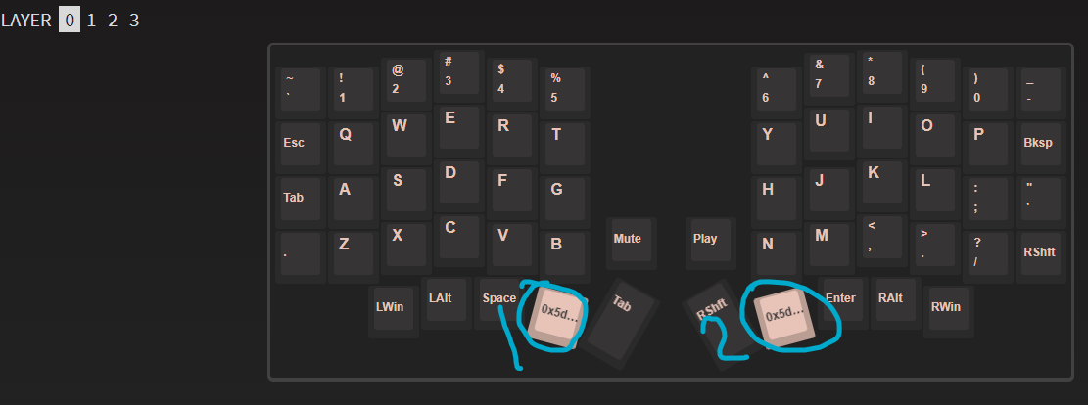

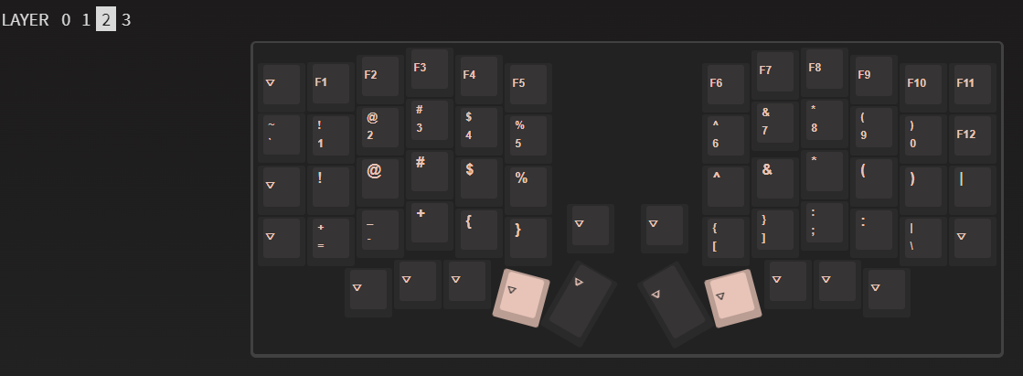

Keys on layer 3, control the RGB colors, switch to WIN/MAC mode, and control your music player on the computer, for example:

To switch between Windows/Mac mode, while holding keys 1 and 2, press key 3. The OLED screen on the left side should display which mode it is currently in.

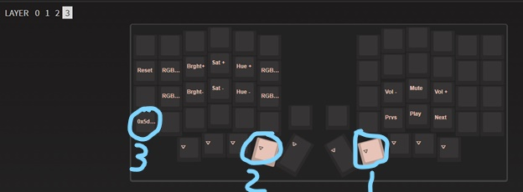

To change pre-programmed led “motions” (i.e. animations), again, press and hold keys 1 and 2, and then either press the marked “up” and “down” keys to cycle through the animations.

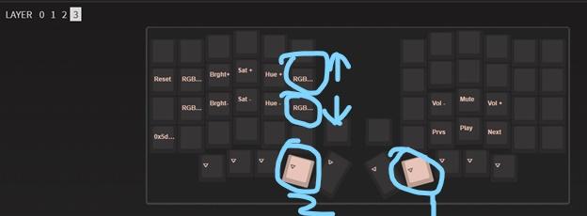

And so forth… follow the same key combinations to change the “Saturation +/-”, “Brightness +/-”, and “RGB speed +/-” (sorry, this is truncated in the picture below).

**Getting up to speed: *practice, practice, and more practice…***

Well, that’s pretty much it for setup. Besides finding the perfect keymap (cough cough: check out my personal VIA keymap JSON from my GitHub link above). Next is the real hard part: typing on a ortholinear keyboard if you’re used to the traditional staggered layout.

Here’s my personal (short version) back story on how I got started with these types of keebs, and maybe give you some motivation to stick with it. I started a new role at work where I was typing A LOT more, and I started developing carpal tunnel/shooting pains in my right hand. Not good…, at this rate, I might be doing some long term damage I thought, besides it not being bearable. Anyways, after stumbling on the Sofle Choc, I built it (which was a joy and I got hooked), I started typing and my WPM dropped from ~85 WPM to ~20 WPM, going from typing always on staggered traditional keeb to a ortholinear felt like I was learning to type all over again. No joke. Long story short, after an initial struggle that lasted about 1-2 weeks, my WPM slowly climbed back to respectable levels and then after 6 months plus, back to ~85-90 WPM. What wasn’t back was the shooting pain and hasn’t come back since.

Bottom line, at least for me, it was worth the time and effort spent. So stick with it!

A fun, free way to practice is <https://monkeytype.com/>

Congratulations on your new Sofle Choc, I really enjoy my Sofle Choc, and I hope your new one serves you just as well or better!